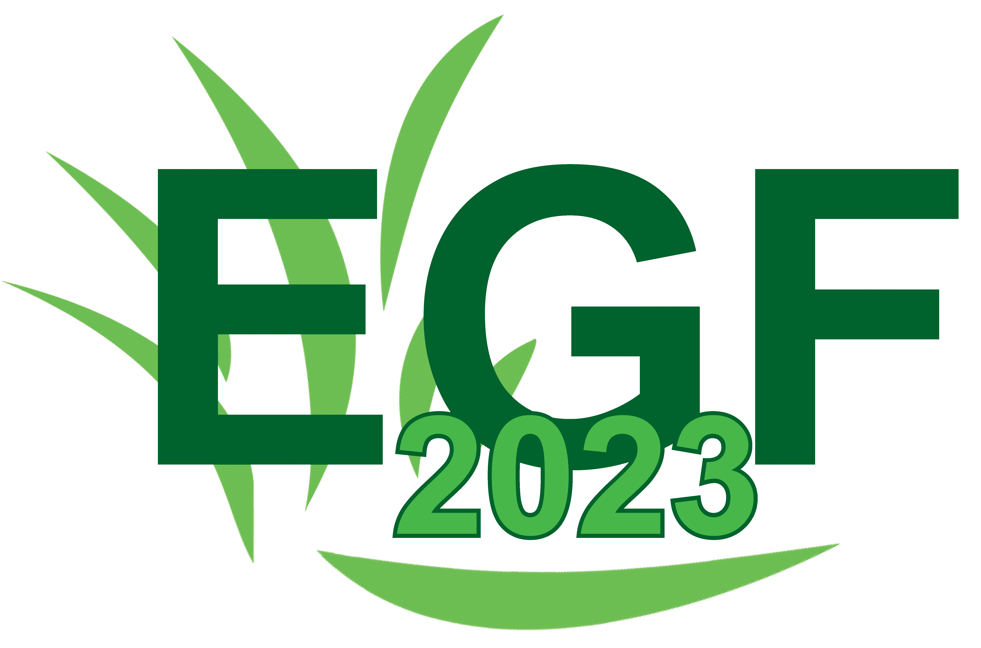
Requirements for applications to the “Stapledon Memorial Trust Award for European Early Stage Researchers” for the EGF 2023 Symposium in Vilnius

The Stapledon Memorial Trust have awarded EGF 2023 funding to support young Early Stage Researchers from Eastern and Southern Europe to attend the symposium in Vilnius in June 2023. Successful applicants will get a reduction of 280 EUR for their symposium fee.
• Be younger than 35 on the 11th June 2023 (copy of passport required) or have completed your PhD later than January 2018 (please provide date of graduation).
• Have submitted a paper for the symposium as a first author and have it accepted for an oral or poster presentation.
• Personally present the paper (oral or poster) at the symposium.

If you wish to apply for the grant, please email your letter of motivation to receive the award supporting the participation in the EGF2023 Symposium, proof of age (copy of passport) or graduation to egf2023@lammc.lt not later than deadline for early bird registration.

